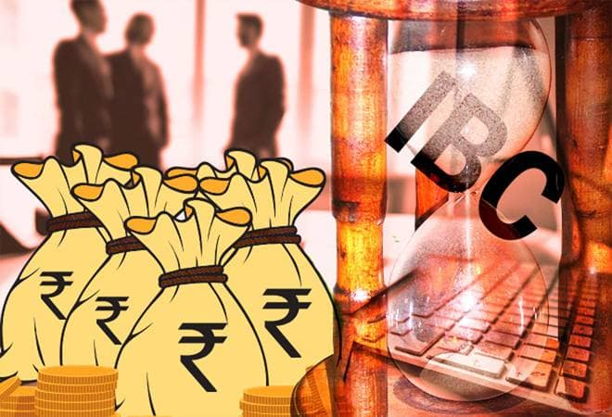

Date: December 18, 2019 Time: 5.00 pm -8.00pm
IMC Chamber of Commerce and Industry & IP Foundation is organizing “Fireside Chat: Quo Vadis Insolvency and Bankruptcy Code IBC”.

Overview
Insolvency and Bankruptcy Code 2016, has been a most evolving laws in present time. The code from the date notified till date has changed at a great pace so are the judicial pronouncement on the subject matter. The initial emphasis on giving opportunity to ailing corporate debtor to reorganize itself and resolve liquidity issues to banning there entry as resolution applicant and then again allowing MSME corporate debtor suspended management to regain control. The discussion on how Insolvency and bankruptcy code evolved in last two year and what does the expert feel on where it is heading.

Who can Participate
CA, CS, COST ACCOUNTANTS, INSOLVENCY PROFESSIONAL, CFO, CLO, ADVOCATES.

Benefits to Participants
- Detail understand on various perspective of resolution plan
- Assist them in preparation of plan
- Assist to have effective Merger and acquisition structure under Insolvency and Bankruptcy Code.
REGISTRATION
Venue: Library Lounge, 2nd Floor, IMC Bldg, Churchgate 400020
Kindly use the following website for online registration: www.imcnet.org.
The fees for the seminar is Rs. 2,000/- per participant (inclusive of GST)
For further details please contact Ms. Anita Naik at anita.naik@imcnet.org or Phone: 022 71226686

We cordially invite you to attend this panel discussion. Registrations are mandatory due to limited number of seats and will be on First come First serve basis.

We look forward to your participation.

Ajit Mangrulkar
Director General

Program Schedule

4.30 to 5.00 pm | Registration and Networking
5.00 to 7.30 pm | Moderator:  - CA Snehal Kamdar  IP Foundation  Panelist  - Adv. Aashit Shah  Partner, J Sagar Associates  - Mr. D S Shekhawat  GM , Bank of India  - CA Avil Menezes  Avil Menezes & Co
7.30 to 8.00pm | Q & A followed with Concluding Remarks

